WEEK-8
AIM:
List the software requirements for the installation of Django.
SOFTWARE REQUIRNMENTS:
- Install Python:
- To check if python installed on your machine, open command prompt and run following command
- python --version
- OUTPUT
  - If python is installed, Python 3.10.0 (version number may change)
  - If python is NOT installed, 'python' is not recognized as an internal or external command, operable program or batch file.
- Install Django package:
- Open command prompt Run any one of the following commands
  - pip install Django OR
  - py -m pip install Django
- You can tell Django is installed and which version by running the following command
  - python -m django –version
- Install Visual Studio Code (VS Code)
- To check if VS Code installed on your machine, open command prompt and run following command
- code --version
- OUTPUT
  - If vscode is installed, 1.83.1 (version number may change)
  - If vscode is NOT installed, 'code' is not recognized as an internal or external command, operable program or batch file.

WEEK-9
AIM:
Creating a Django project on windows
PROCEDURE:
- Create workshop folder:

Create a folder as C:/workshops/django/

- Open Command Prompt from the File Explorer :
Type "cmd" into the address bar and press Enter to open the Command Prompt with the path of the current folder already set.

- Create a Django Project:

Navigate to the directory where you want to create your Django project and run the following command to create a new project with the name "demo_project"

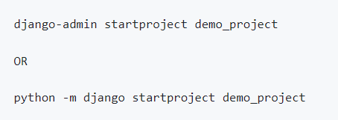

4.Navigate to the Project Directory:

Change your working directory to the newly created project folder

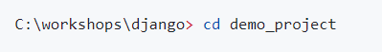

5.Initialize the Database:
Django uses a database to store information about your project. You'll need to create the database schema and tables by running the following commands:
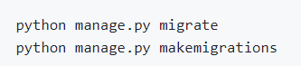
5.Create a Superuser:
You can create a superuser to access the Django admin interface for managing your application. Run the following command and follow the prompts to set user credentials (you can set user = admin and password = admin):

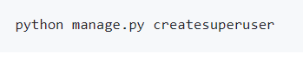
6.Start the Development Server:
To run your Django project locally, use the development server. Run the following command
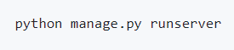
7.Access the application in browser:
- http://127.0.0.1:8000/ (change the port number if app is running on a different port)
- http://127.0.0.1:8000/admin/ (change the port number if app is running on a different port). Log in with the superuser credentials to manage your application.

OUTPUT:
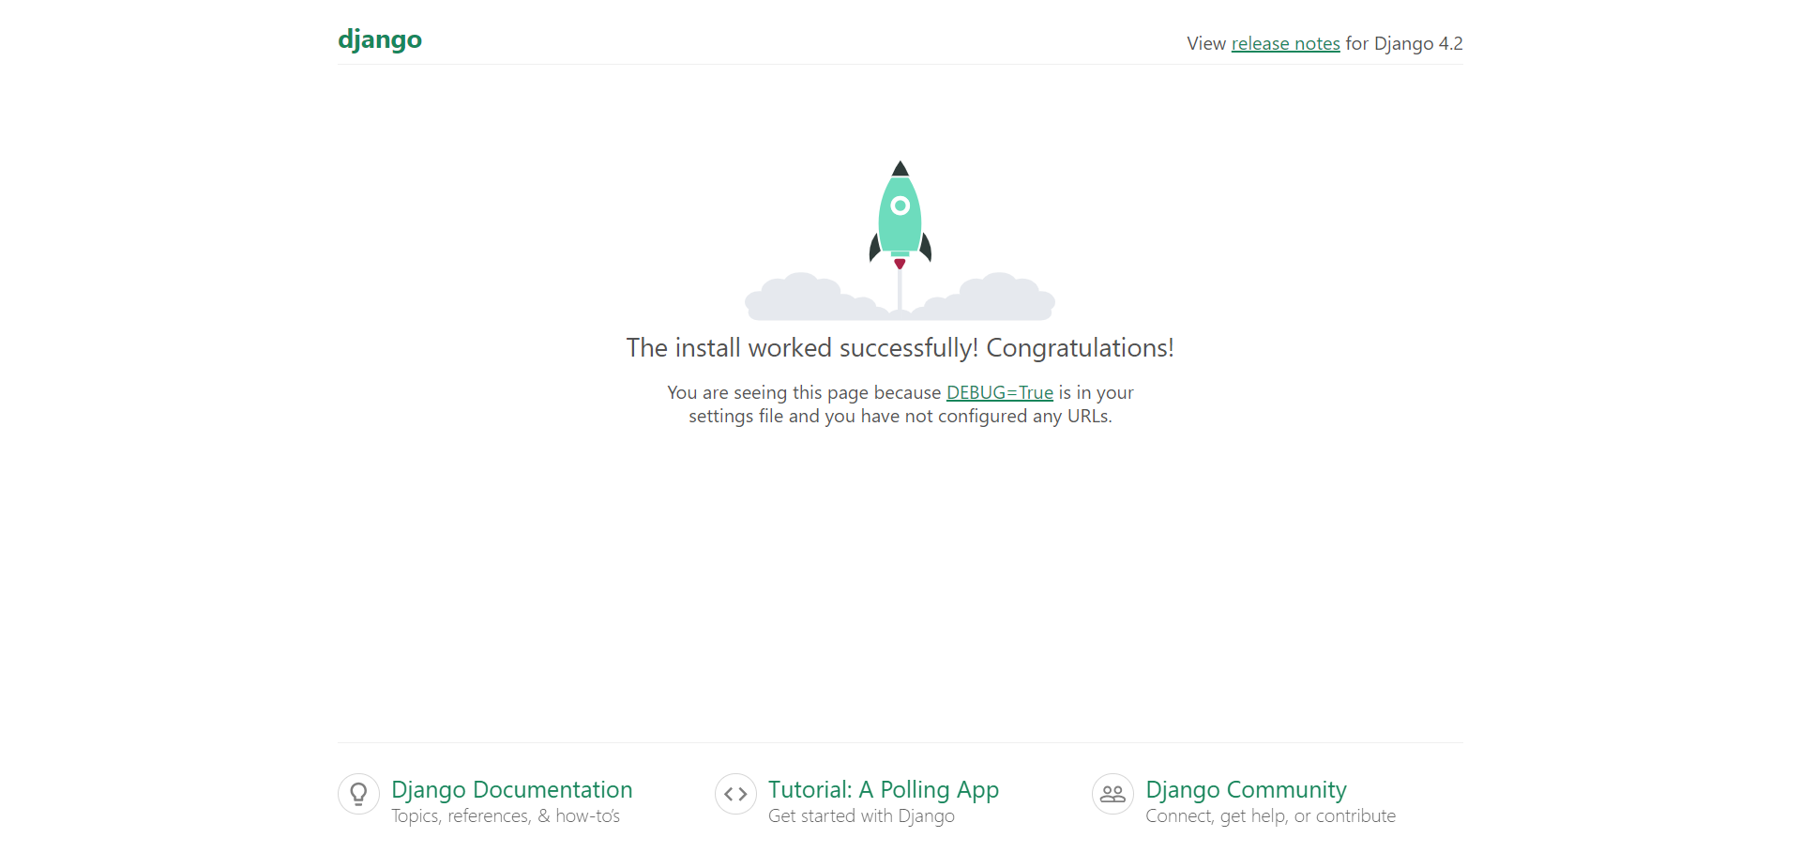

Week-10

AIM:

Create a Django app

PROCEDURE:

  - Create app:
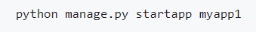
Django creates a folder named members in my project, with this content
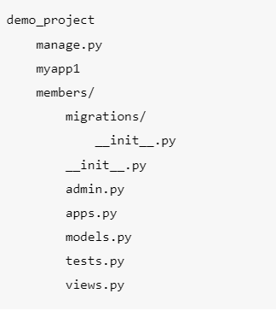

2.Add/Update Views:
- Go to myapp1/views.py
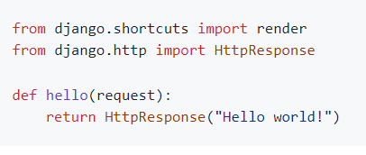

3.Define URLs
- Create a file (if not there already) named urls.py in the same folder as the views.py file in the app
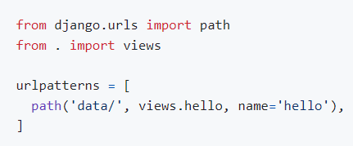
- The urls.py file you just created is specific for the app. We have to do some routing in the root project level as well.
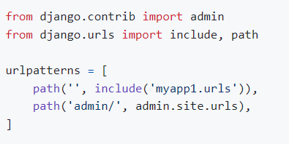

4.Run Server:

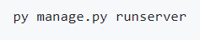

In the browser window, type 127.0.0.1:8000/data/ in the address bar.

OUTPUT:

